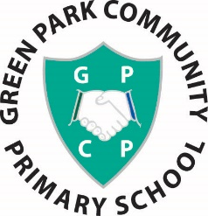
Our school values
At Green Park, we value children and their individuality, but we also recognise that there are key values that children will need to hold to become successful in the world. These values are taught and referred to throughout the school and form an intrinsic part of teaching, learning and our reward systems.
Each value has its own character, making it more relatable to the children. Teachers also have resources to enable them to teach the values while children are given opportunities to develop and test their own characters by applying the values to daily events.

Laura Olly Raj Izzy Charlie
Our values are:
Leadership- Laura
- Leading others
- Explaining my leadership
- Listening to my team
- Keep calm and ask for help
Organisation- Olly
- Organising myself
- Organising an activity
- Organising together
Resilience- Raj
- Keep on going
- Who can help
- Meeting the challenge
Initiative- Izzy
- Taking responsibility
- Taking part
- Sharing ideas
Communication- Charlie
- Communicating with others
- Knowing my audience
- Sharing my opinion

