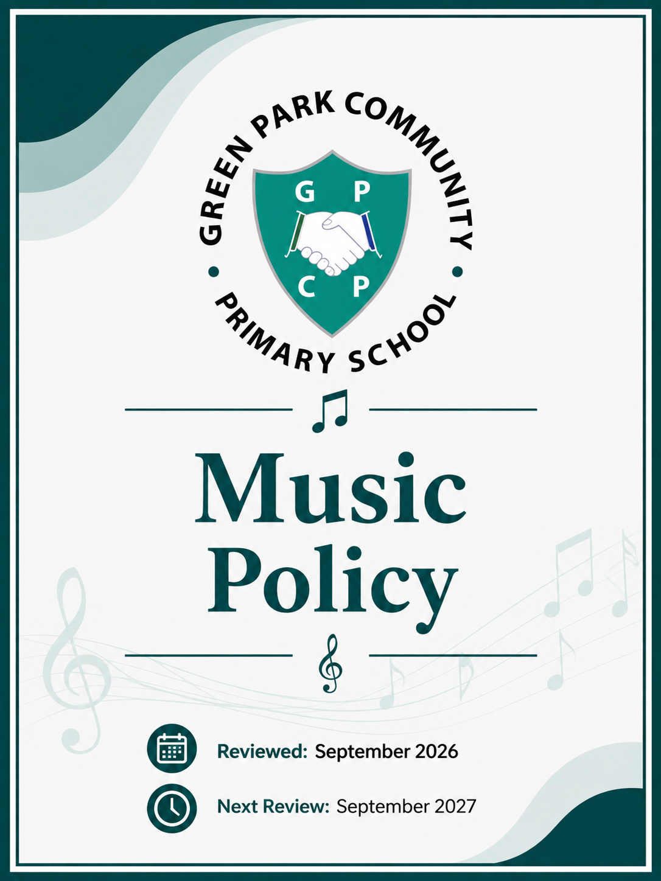

The Importance of Music

According to the new National Curriculum: “Music is a universal language that embodies one of the highest forms of creativity” 2014.

Music is a practical, creative subject, which can benefit all children in developing imagination, the ability to listen attentively, and the ability to be able to express personal thoughts, opinions and feelings. It also plays an important part in helping children to feel part of a community.

Aims

Our aim in music is to:
- develop an understanding and enjoyment of creating music.
- give children the opportunity to control sounds through singing, playing and performing.
- encourage the children to respond to and review musical structures, sounds and effects, musical vocabulary and expression.
- help children to develop their ability to listen and apply their knowledge and understanding in their musical experiences.
- use music to enhance learning across the curriculum.
- recognise the ways in which ICT can be used to extend the children’s musical experiences.
- give children an enjoyable and stimulating experience of music which will encourage them to develop their own skills and continue enjoying music throughout their lives.
- enable children to develop their musicianship to enhance their personal, social and emotional skills and to enjoy performing together to a variety of audiences.

Curriculum

The National Curriculum for music aims to ensure that all pupils:
- perform, listen to, review and evaluate music across a range of historical period, genres, styles and traditions.
- learn to sing and use their voices, to create and compose music on their own and with others, have the opportunity to learn a musical instrument, use technology appropriately and have the opportunity to progress to the next level of musical excellence.
- understand and explore how music is created, produced and communicated, including through the inter-related dimensions: pitch, duration, dynamics, tempo, timbre, texture, structure and appropriate musical notations.
- increase their self-confidence, creativity and sense of achievement.

EYFS
We teach music in the Reception class as an integral part of the topic work covered during the year. As part of the Early Years Foundation Stage of the National Curriculum, we relate the musical aspects of the children’s work to the objectives set out in the Early Learning Goals (ELGs). Music contributes to a child’s personal and social development. Counting songs foster a child’s mathematical ability, and songs from different cultures increase a child’s knowledge and understanding of the world. In addition, Reception class has access to the Charanga Music Scheme.

KS1 and KS2
Our school uses the Charanga Music School scheme as the basis for its curriculum planning. This scheme has an integrated, practical, exploratory and child-led approach to musical learning.

The learning within this scheme is based on:
• Listening and Appraising,
• Musical Activities (including Creating and Exploring)
• Singing and Performing.

While there are opportunities for children of all abilities to develop their skills and knowledge in each unit, the progression planned into the scheme of work means that the children are increasingly challenged as they move through the school. All musical learning in the scheme is based around the Interrelated Dimensions of Music: pulse, rhythm, pitch, tempo, dynamics, timbre, texture, structure and notation.

Music lessons are provided by class teachers in a dedicated weekly music slot. The Charanga scheme is followed for five of the six terms. Replacing the Reflect, Rewind and Replay units are teaching blocks dedicated to learning a given instrument or songs for a performance:
Year 1 learn Nativity songs.
Years 2 and 3 learn Ocarinas using Ocarina 123.
Years 4 and 5 learn Recorders using Charanga units.
Year 6 learn Musical songs.
These instruments, as well as the glockenspiel, are further developed within the other Charanga units.

Assessment

Children demonstrate their ability in music in a variety of different ways. Teachers will assess children's knowledge and understanding by questioning, listening and observation of performance in class as an ongoing process. Assessment grids are provided by Charanga Music for individual lessons and at the end of each unit for teachers to record their observations.
Recorded performances (audio or video) are excellent means of keeping evidence within this subject and can be used by children for self-assessment; older and more able pupils are encouraged to make judgements about how they can improve their own work.
For each unit of work, teachers will upload two videos of their class performing key musical skills (e.g. singing, playing, composing, improvising etc.) to the staff shared drive as evidence of progression.
Three times a year, teachers make a summary judgement about the work of each pupil in relation to the National Curriculum level of attainment using an End of Year Expectations grid derived from the objectives of the Charanga music scheme. Information on a child’s progress in music will be communicated to parents in the written report once yearly.

Music Across the Curriculum

Music has many natural links to other areas of the curriculum. Teachers supplement weekly music lessons, providing cross curricular music and additional music making experiences linked to their topic where appropriate. These include:
- Literacy - the extension of vocabulary through discussion, the use of pulse/rhythm in poetry and as the stimulus to creative writing and drama.
- Maths - the sequencing, symmetry and structure of music and the use of patterns, counting and time.
- Science - how sounds are made, how they travel and how they are heard.
- Computing - recording sound, using electronic sound sources and music software.
- History - music commemorating events and traditions; music from different times.
- Geography - music from the UK and from other countries; instruments from around the world.
- RE - songs and music for religious festivals.
- PE - moving and dancing to rhythms and music.
- PSHE - emotional responses to different musical stimuli.
- Art - using Art and DT as visual stimuli and representing music through art forms.
Music also contributes to the key skills of listening, memorising, communication, language, co-ordination and sequencing. Music develops social skills and is important to the spiritual and cultural growth of pupils.

Extra-Curricular Music

Children regularly take part in singing practice during assemblies and in a weekly singing practice. There are also free lunchtime and after school clubs for children to join, learning the ocarina, recorder, guitar and to sing and sign.

Opportunities are provided to perform in public, for example, groups of children have been invited to sing in the local community to raise money for charity, perform in Christmas services or in local care homes, while parents and friends are invited to attend concerts given by children learning an instrument.

At Christmas time, the Reception and Year 1 children rehearse and present a nativity performance, while the rest of the school perform at a Christmas Concert to family and friends. Again in the summer, the children sing as a collective, in classes, in groups and individually at the School's Summer Concert. At other times of the year, individual year groups are invited to provide musical entertainment appropriate to the season or the topic they are studying, whilst the children in Year 6 prepare and present an end of year musical performance in Term 6.

Health and Safety

Pupils will be taught the correct and safe way to carry and use instruments and electrical equipment to avoid injury to themselves or others. They will also be taught the correct way to hold and play their instrument. Instruments which are blown will be suitably disinfected. Electrical safety will be assured wherever mains electricity is used, notably with computers, electronic keyboards and audio equipment with teachers ensuring that electronic equipment is only used adjacent to main power points. Annual electrical tests will be undertaken in line with school policy. It is important that teachers monitor and control the use of amplifiers and, in small rooms, large percussion instruments in order that hearing is not damaged.

Resources

- Four class sets of Ocarinas and Ocarina 123 Screens.
- Four class sets of Recorders.
- Once class set of Chime Bars.
- Two class set of Glockenspiels.
- Four class Untuned Percussion sets.
- Additional recorders and a variety of tuned and untuned percussion instruments (including Boom Whackers) in the Music Cupboard located adjacent to the hall.
- Charanga Musical School license, renewable annually, which provides units of study, instrument teaching units, Yumu app for children to engage with in school or at home and extensive staff CPD.

Professional Development

Opportunities for CPD are available through Charanga and Kent Music Hub. Staff are regularly pointed to useful tools to support their teaching in whole staff meetings and can request further support from the Music Lead if desired.

Role of the Subject Leader

The coordination and planning of the music curriculum are the responsibility of the subject leader, who also:
• keeps colleagues and school governors informed about developments in music and provides a strategic lead and direction for the subject
• discusses progress with the Creativity Team and evaluates strengths and weaknesses in music resulting from monitoring (drop ins, pupil voice, assessments)
• reviews the success of the Charanga music scheme and reviews evidence of children’s work
• arranges external music providers to work with different year groups

SEN Adaptations

Music is a subject that is accessible to all abilities and nationalities and it is very important that every child is allowed access to this. Musical activities are particularly effective in the education of children with learning disabilities of any kind, ranging from physical to social and emotional problems.

Music is broad and “open-ended”, providing opportunities to solve problems, to work independently, to work as a group and to be responsible for self-regulation. In music it is important that every child feels comfortable and is able to demonstrate their musical skills and compositions without feeling embarrassed, thereby promoting their confidence and ability.

Cognition and Learning
Barriers |  | Provision
Difficulties following or reading music.  Retention of long pieces of music for performance. |  | - Support with colour coding of notes or providing the written letter to assist with music reading.  - Opportunities for overlearning and repetition.  - Child provided with their own music to listen to in advance of the lesson or listen to at home.  NB Many children with learning difficulties are able to excel in Music and therefore need to be aware of individual profile of need.
Communication and Interactions
Barriers | Provision
Learning of new vocabulary/technical vocabulary. | - Explicit teaching of new and technical vocabulary.  - New vocabulary displayed with visual aids, symbols, and demonstrations to illustrate the meaning.  - Use recordings for children to demonstrate their knowledge, rather than explaining it. For example, can demonstrate and record change in volume or pitch rather than trying to explain it.  - Carefully considered groupings/pairings.
Physical and Sensory
Barriers | Provision
Noise sensitivity – either through hearing aids or due to sensory processing difficulties.  Access to the instruments. | - Child to be prompted to adjust hearing aids/radio aid if applicable.  - Ear defenders for children who will find the noise level difficult.  - Warning of any loud or unexpected noises (clashing symbols etc.).  - Consider pupil sensory audits and adaptations.  - Access to adapted instruments (can be home-made adaptations to assist with grip etc.).  - Use of technological musical solutions to overcome physical barriers.  - Liaison with outside agencies regarding specialist support and appropriate noise levels for hearing impaired children.
Social Emotional and Mental Health
Barriers | Provision
Anxiety about new or different experiences or having to perform.  Difficulty regulating behaviour or coping with others who are not regulating their behaviour in a noisy/busy environment. | - Social stories and clear explanations before new experiences to explain what will happen and provide opportunities for children to ask questions.  - Opportunities to share their work in different ways, for example; behind scenes, pre-recorded, quieter areas of school.  - Shared signals for stopping which are pre-agreed at the start of the lesson to provide security for the child.  - Visual cards for child to show that they are feeling overwhelmed.  - Opportunities to develop social skills including being taught these discretely to support engagement in group work and collaborative learning.  - Use of PSHE to discuss healthy relationships, promote well-being and explore emotive topics within learning.

