
Message from Mr. Hawkins

Dear Parents and Carers,
As the end of term fast approaches, I’d like to thank you all for your support and encouragement over the week, as Ofsted visited our school. What a time to come! It does mean though, that we can all enjoy a well-deserved summer break and start the new year without worrying about them calling. I can’t share the outcome of the inspection with you, but the inspectors were very fair and the children were marvellous.
This year, we have celebrated so many achievements it’s hard to name them all. The children have made tremendous progress and we’re hoping for our best SATs results for a number of years.
In sports, our football teams produced some wonderful performances and there is much talent to be excited for next year. We had magical performances for the Summer concert and the Music Day at the Duke of Yorks Military School.
Congratulations go to Mrs Marsh, who is now a fully qualified teacher, having completed her Teaching Apprenticeship with us.
Our good wishes go to Mrs Page and Miss Thomason, who are off to have their babies over the summer. Miss Wilson is returning from maternity leave in September.
Please remember that staff will not be answering e-mails over the summer holidays. I monitor my emails for any emergencies.
I hope you have a wonderful summer with your families and look forward to seeing you all on September 2nd.

Mr Hawkins

This Photo by Unknown Author is licensed under CC BY
July Newsletter
Green Park Community Primary School
Dates for your diaries:

17th July – Last Day of Term
1st September – Development Day (No children in school)
2nd September – First Day of Term
4th September – Year 4 Trip - Viking Ship
7th September – EYFS Children start (8.45am – 1pm)
8th September – Year 5 Trip – Monkton Nature Reserve
14th September – Coffee Morning – Main Hall
14th September – EYFS Children Full Time
14th September – Year 2 Trip – Dover Castle
15th September – Year 6 Trip – Ramsgate Tunnels – Royal Class
16th September – Year 6 Trip – Ramsgate Tunnels – Brompton Class
17th September – Year 3 Trip – Dover Castle
25th September – EYFS – Visit from ‘Jaws n Claws’
9th October – Individual and Family Photos
13th October – Year 4 and Year 5 – Come and Look
14th October – Year 1 Trip – Wingham – Hyde Class
15th October – Year 1 Trip Wingham – Richmond Class
w/b 19th October – Year 6 - Residential
19th October - Year 1 – Come and Play
20th October – Year 2 and Year 3 – Come and Look - 2.15pm
22nd October – EYFS – Halloween Come and Play
23rd October – Prize Assembly – 9am
23rd October – Halloween Disco (Whole School) –
Children to bring costumes in a named bag please
23rd October – Last Day of Term

Please note that these dates are subject to change.
If any changes are made, letters will be sent out to Parents/Carers.
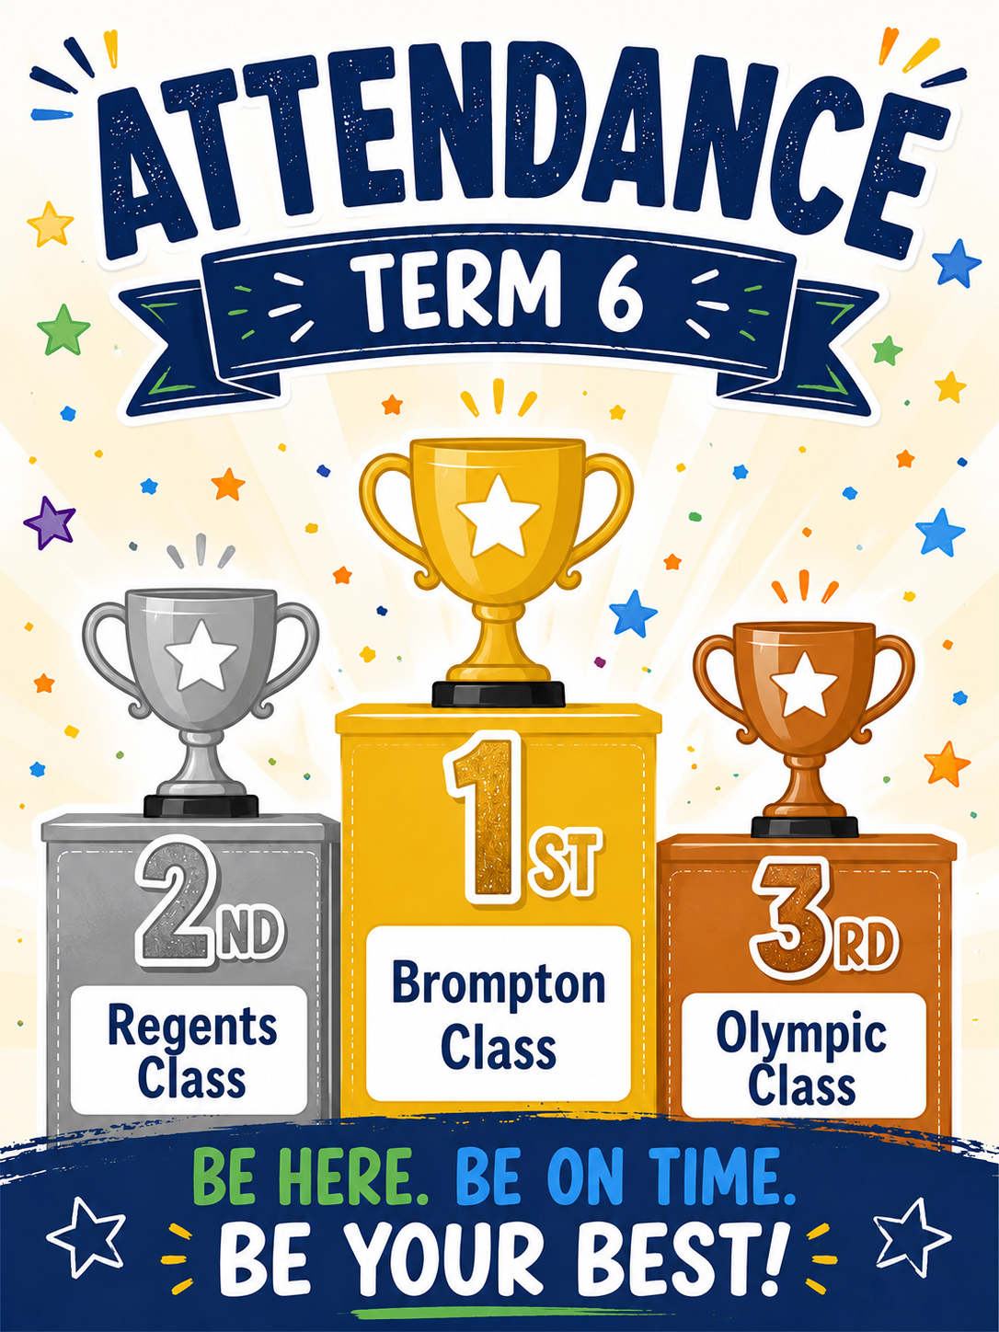
Congratulations to Our 100% Attendance Champions! 🎉
A huge congratulations to the following children who achieved 100% attendance throughout the entire school year and receive a voucher to spend.
What a fantastic achievement.
- Kalen – Year 6
- Taylor – Year 6
- Erikas – Year 6
- Tommy – Year 5
- Logan – Year 4
- Emmerson – Year 3

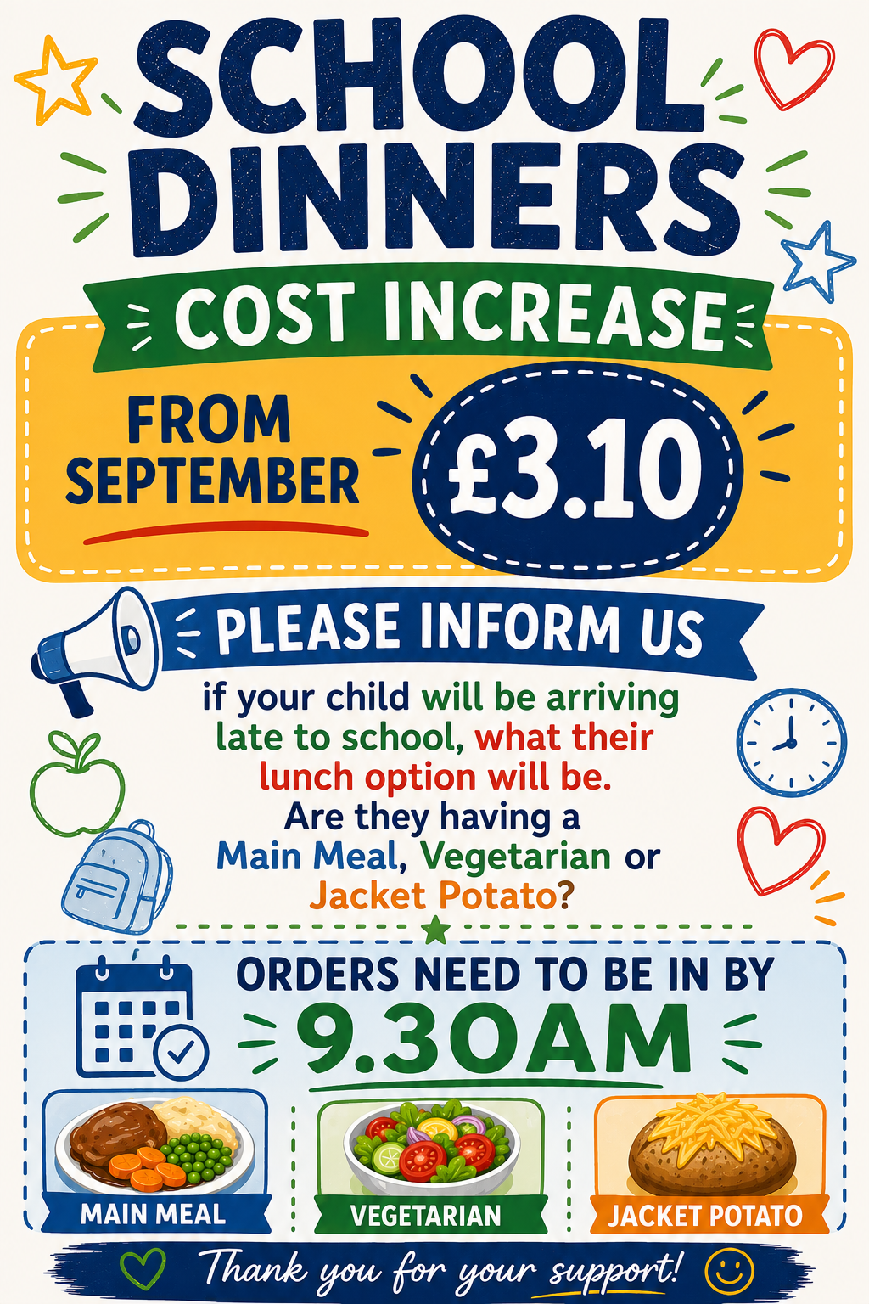
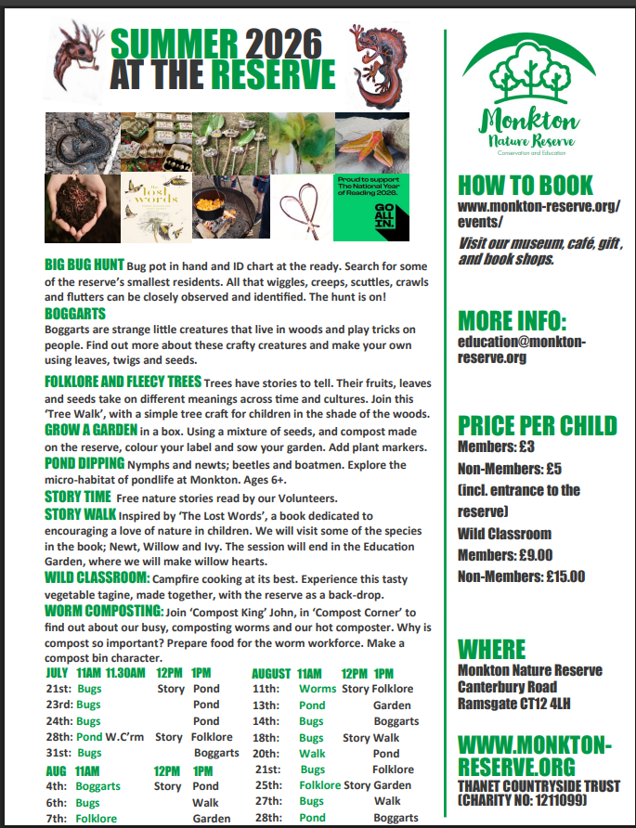

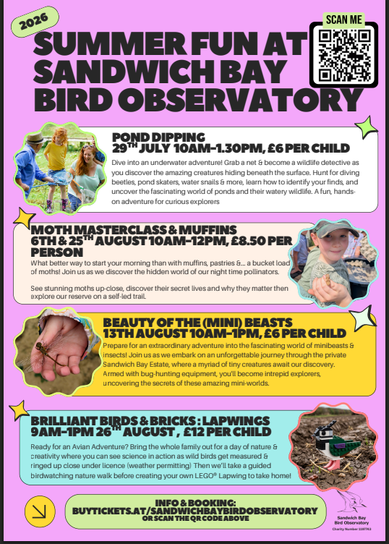
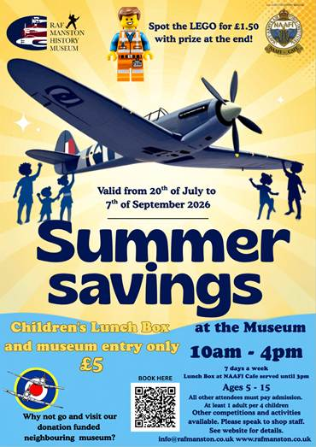
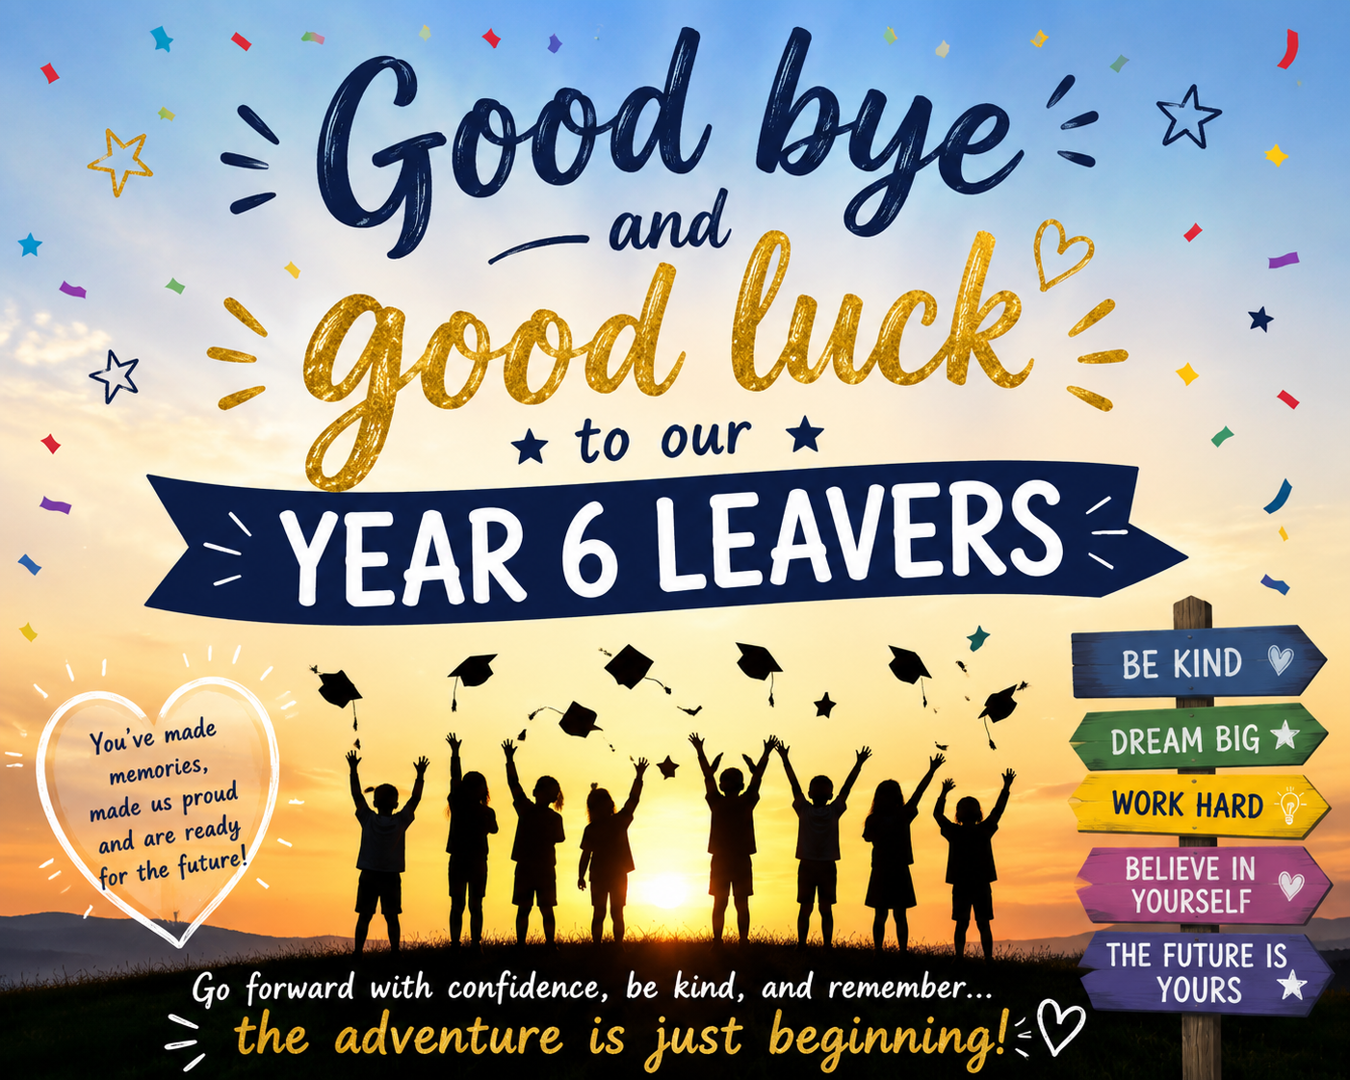

Have a lovely Summer Break
Stay Safe!



CHILDREN ARE BACK TO SCHOOL ON
Wednesday 2nd September 2026

