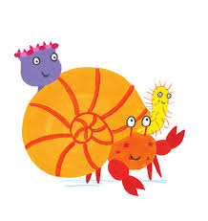
CLL – Communication, Language, and Literacy

Throughout the term we will be looking at lots of different stories such as:
- Sharing a Shell
- The snail and the Whale
- The Night Pirates.
- Save the Ocean
- The Singing Mermaid
As we are now writing sentences, we will be using our sentences to tell these stories, as well as describing a mermaid and writing a postcard. We will be continuing to learn our digraphs and trigraphs in phonics and use these to read words. We will also continue practicing recognising and writing tricky words.

Targets: Write recognisable letters, most of which are correctly formed. Spell words by identifying sounds in them and representing the sounds with a letter or letters. Write simple phrases and sentences that can be read by others.

Topic Web
Term 6 – On the Beach

PSED – Personal, Social and Emotional development

Throughout this term we will be looking at a variety of books which follow storylines about kindness; this will lead to conversations with the children about friendships and how we help others. We will also be working on transition to Year one by the children spending time with their new teachers in their new classrooms.

Targets: Show an understanding of their own feelings and those of others and begin to regulate their behaviour accordingly. Show sensitivity to their own and other’s needs.

M – Maths
This term the children will continue to gain a deeper understanding of numbers to 20, including the composition of each number. They will continue to use these numbers to solve simple maths problems, including double facts, sharing equally and odds and evens. The children have worked hard to count to 20 and beyond and this will continue throughout term 6. We will also touch upon positional and directional language.

Targets: Have a deep understanding of number to 10, including the composition of each number. Explore and represent patterns within numbers up to 10, including evens and odds, double facts and how quantities can be distributed equally.

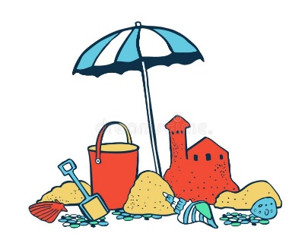

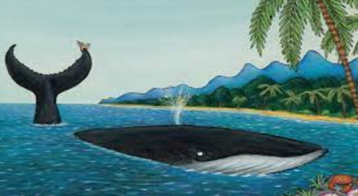
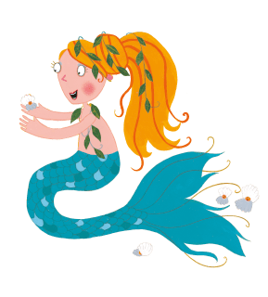

EAD – Expressive Arts and Design
This term we will continue role playing the stories we read and re telling them using props and adding music. We will also be making our own pirate treasure maps to help us find hidden treasure. We will also be making snails using puff pastry, shell moulds in clay and painting pebbles.

Targets: Safely use and explore a variety of materials, tools and techniques, experimenting with colour, design, texture, form and function.


Our aim is to keep learning fun and exciting for all the children in Palace Class, therefore sometimes we will adapt and change our plans to suit their needs.
PD – Physical Development
This term we will be exploring dance and relating it to our topic. We will also be taking advantage of the warm weather and using the field for running races, team games and climbing on the obstacle course.
For our fine motor skills we will continue to use playdough, tweezers and string, but we will also explore padlocks and shells to link with our topic.

Targets: Negotiate space and obstacles safely, with consideration for themselves and others. Demonstrate strength, balance and coordination when playing.



