
History and Geography

In history this term we will be learning all about the history of London. In particular, we will focus on the Great Fire of London. We will be researching the key events, and looking at how that impacted London.
In Geography we will be looking at the countries that make the United Kingdom as well as the capital cities.

PE

This term, the children will be taking part in Attack, Defend, Shoot topic where they will be learning to recognise rules and how to apply them in competitive and corporate games.

Please remember to send your child’s PE kit back to school on the first day back after half term.

English

Throughout this term we will be taking a virtual trip to London on a bus tour, having an afternoon tea with the King, and learning all about The Great Fire of London where we will be writing a diary entry from Samuel Pepys, learning all about where and how the fire started and why it spread so quickly.



Topic Web
Term 6 – Bright Lights, Big City


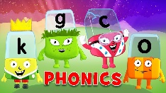
Maths

This term, we will be working on numbers to 100. We will be partitioning numbers using base ten, finding one more and one less than a given number, looking at o’clock and half past times, learning about different values of money, measuring using rulers and capacity.

Phonics

This term, we will continue with The Little Wandle scheme, and the children will build upon their phonic knowledge, focusing on introducing more digraphs and trigraphs and to use these in their writing. We are also doing daily reading groups which are linked to their phonics learning.

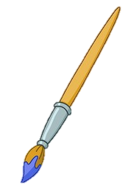

Art and DT

In term 6, we will be designing and making our own London bus, and making a London skyline from junk modelling. We will also paint scenes from the Great Fire of London.

Special experiences

This term we will be meeting our new teachers during transition week. We will also have an end of term trip to the beach and a graduation party.


Our aim is to keep learning fun and exciting for all of the children in Year 1 therefore sometimes we will adapt and change our plans to suit their needs.

