
Message from Mr. Hawkins
In the school year, Term 5 is nearly always the shortest, but also the busiest. This term has seen Year 6 children take their SATs tests in Reading, GPS and Maths. We’ve also managed to hold 2 of our 3 sports days (the weather gods finally smiled on us) and the children have taken part in trips to Richborough Fort, Kearsney Abbey and Betteshanger Park.
I must commend our Year 6 children for the way they approached the SATs tests. It was clear that the hard work the children and staff have been putting in is paying off- they took the tests with confidence and knowledge, and I hope their results will reflect their endeavours.
It was wonderful to see the children taking part in sports days this week. Sport is such a powerful tool for teaching children about life- learning to be part of a team, accepting success and failure in the right way, working hard and most of all, having fun with friends. As the husband of an Olympian and World Record holder (feel free to ask me about this), I have witnessed first hand the transformative power that sport has. There are so many opportunities for young people to become involved in sport locally. Rugby, Football and Cricket clubs all advertise for children to join up and many of these offer free sessions. Dance and cheer groups are extremely popular and we have tried hard to introduce our children to sports they may never have tried, such has Tennis, which Year 4 have been receiving coaching in this term.
The summer is the perfect time to explore those options and get your child involved.

I hope you enjoy the break- the weather looks set to be great!
Children return to school on Tuesday 2nd June.

Green Park Community Primary School

May Newsletter
Dates for your diaries:

22nd May – Last Day of Term
1st June – Staff Development Day (no children in school)
2nd June – First Day of Term
4th June – New September Intake Meeting 2.15pm
8th June – Class Photos and Year 6 Leavers Photos
9th June – Year 4 – River Dipping – Kearsney Abbey (Kensington Class)
10th June – Year 4 – River Dipping – Kearsney Abbey (Regents Class)
10th June – Science Jamboree
11th June – Years 3&4 – Cricket – Betteshanger (Selected children will be informed)
17th June – EYFS Pirate Day
18th June – Years 4&5 – Kick Rounders – DOYMS (Selected children will be informed)
19th June – Summer Concert – 2pm
22nd June – Year 5 – Local Study
23rd June – Years 5&6 – Cricket – Betteshanger (Selected children will be informed)
24th June – Green Fest – Children Only
w/b 29th June – Transition Week – information will be sent closer to the time
29th June – Year 6 – Meet the Teacher
1st July – Music Day at DOYMS – Letters will be given to children attending
1st July – Years 2&3 – Meet the Teacher
3rd July – Years 4&5 – Meet the Teacher
7th July – Year 6 – Dress Rehearsal
7th July – Year 6 – End of Year Play to Parents – Folkestone Tower Theatre
10th July – iRock Concert – 9am
10th July – Year 6 – Leavers Disco – 4.30pm – 6pm
14th July – Years 2&3 – Class Assembly 9.15am
14th July – Years 2&3 – Summer Picnic Funday
15th July – Years 4&5 – Kearsney Abbey Trip
16th July – Prize Assembly – 9am
16th July – Years 1&2 – Rapid Fire Cricket – DOYMS (Selected children will be informed)
16th July – Year 1 – Colour Run – 2.30pm
17th July – Year 6 – Leavers Assembly 10am
17th July – Last Day of Term

Date TBC – Year 6 SAT’s Treat

Please note that these dates are subject to change.
If any changes are made, letters will be sent out to Parents/Carers.

PE Kits
Years R, 1, 2 & 3
Polite reminder, please ensure that PE Kits are in school at all times
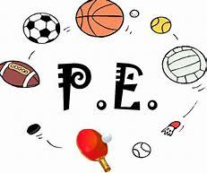

ATTENDANCE
Term 5
 1st – Brompton Class - 97%
 2nd – Regents Class - 95.62%
 3rd – Northumberland Class - 94.63%

Well done for amazing attendance
Keep up the great work!

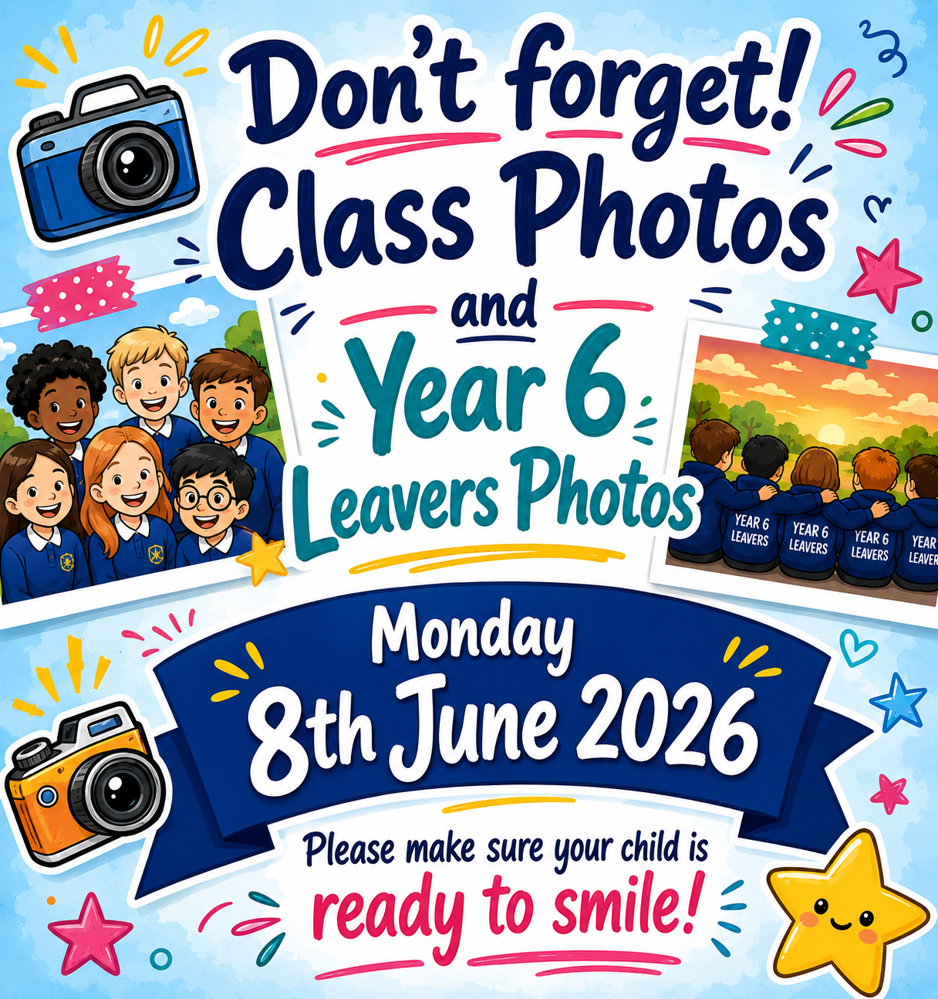
s

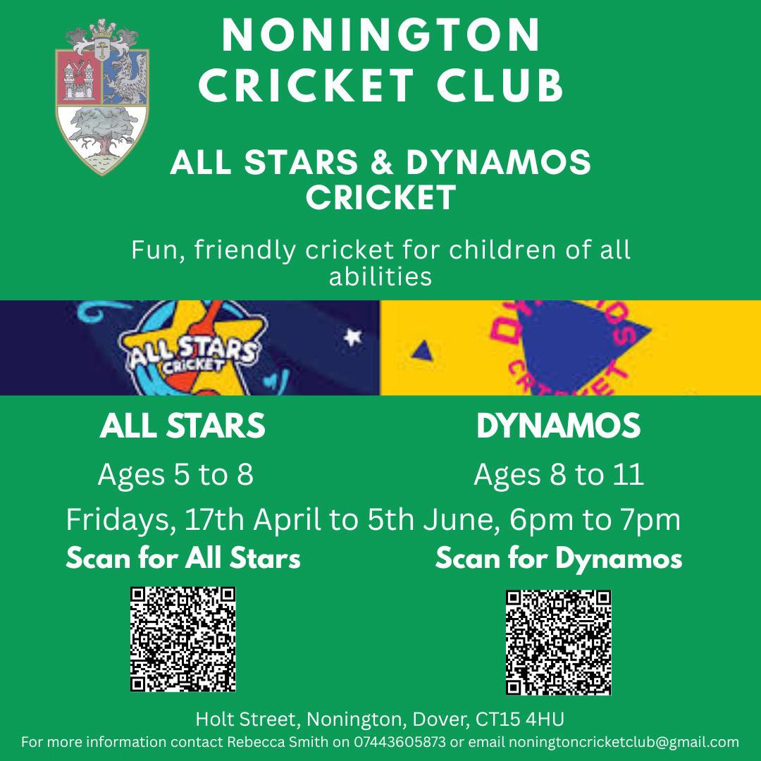
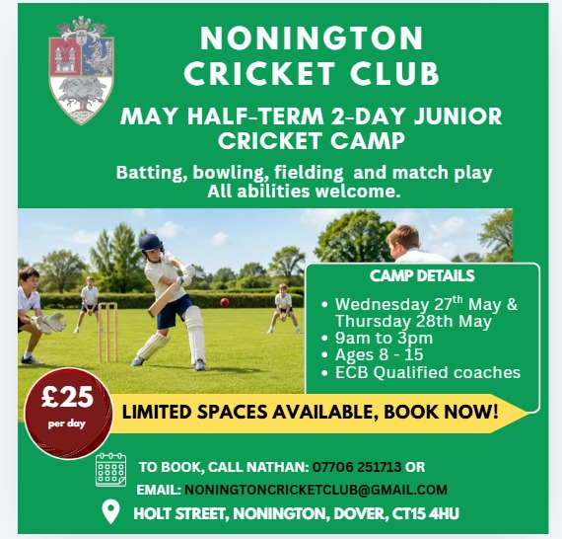

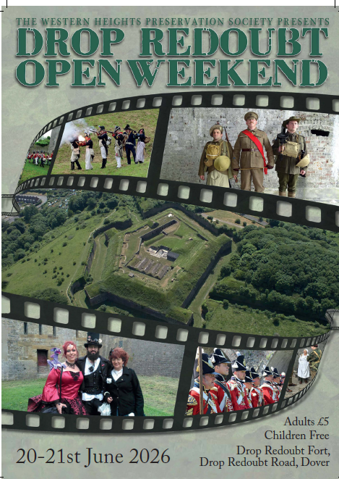

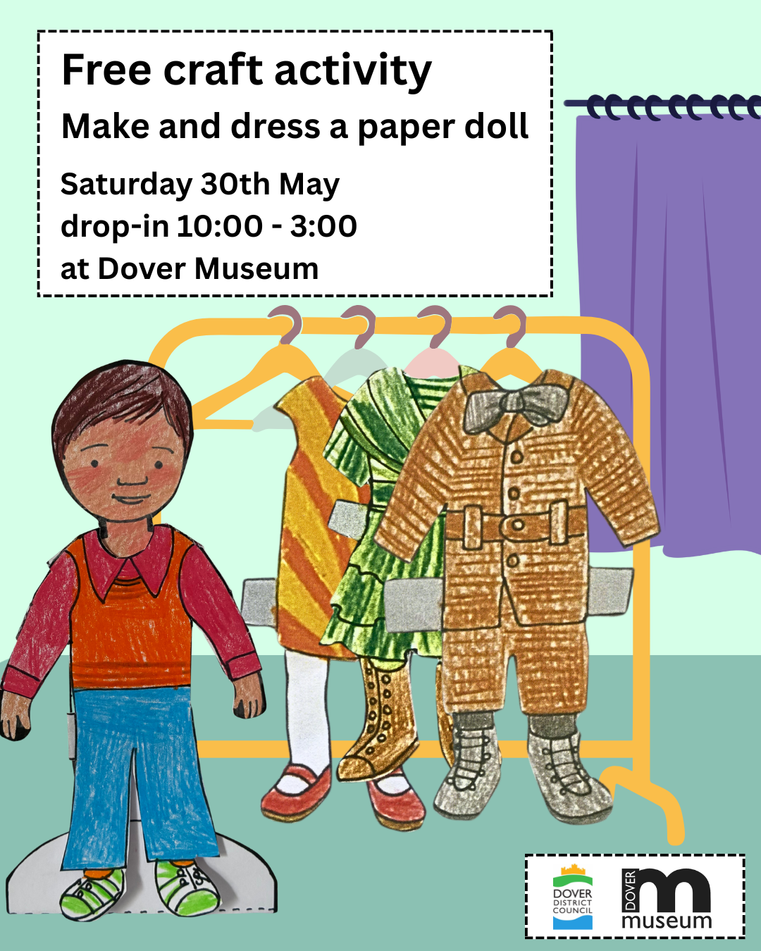

Have a lovely Half Term Break



CHILDREN ARE BACK IN SCHOOL ON
Tuesday 2nd June 2026

