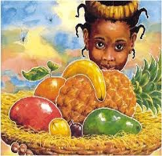
CLL – Communication, Language and Literacy

Throughout the term we will be looking at lots of different books about changes such as:
- How I Grow
- Oi Frog!
- Oliver’s Vegetables
- Jaspar’s Beanstalk
- Handa’s Surprise
- Can you eat a rainbow?

As the children have been introduced to lots of sounds we will be recapping them and the children will be learning to use them in their writing. The children will be using their sounds to re tell and write these stories. Also we will be beginning to write descriptions for example ‘It is big and it is green’.

Targets:
Write simple sentences, in meaningful contexts. Write words which match their spoken sounds.

PSED – Personal, Social and Emotional Development

This term the children will be continuing to work on solving problems without aggression and using their words to tell others how they are feeling. We will also be encouraging the children to organise their own things and think about what resources they need during the day. This will be done by encouraging children to find things around the classroom to help them with their choosing time.

Targets: talk about our feelings and how other people may be feeling, begin, to solve problems without aggression, chose resources they need for their chosen activities.
M – Maths
The children have worked very hard with their numbers recognising and writing them to 20. Over the next term we will be looking at moving beyond 20 and verbally counting. We will continue to practice addition and subtraction with these numbers too. We will be looking at weighing items and continuing to learn our shapes and manipulate them.

Targets: recognise and use numbers from one to twenty to solve simple maths problems. Recognise and name 3D shapes, use everyday language to talk about weight.

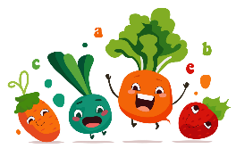
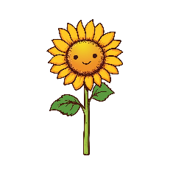
Topic Web
Term 5 – Ready, Steady Grow

EAD – expressive arts and design
This term the children will be learning to make observations of plants and flowers. They will have lots of opportunities to draw flowers to scale and with accuracy. Making sure the colours they use and the correct ones. Using a variety of resources – chalk, paint, glitter, playdough etc.

Targets: Children sing songs, make music and dance, and experiment with ways of changing them. Selects appropriate resources and adapts work where necessary.





PD – Physical Development
This term we will be practicing throwing and catching different objects such as beanbags and balls. We will be using balls to play games where the children will need to control the ball with either their feet or their hands. We will also be experimenting with different way of getting a ball to travel across an area such as throwing, rolling etc.

Targets: handle equipment effectively, show control over an object.
UTW- understanding the world
We will be visiting Frampton Farm this term to see how food grows and how what on the farm is like. Children will have opportunity to ask the farmer questions about their job. We will also be making observations on our class tadpoles and their life cycle. Releasing the frogs back into our school pond.

Targets: Look at similarities and differences, talk about their own environments and how environments may vary from one another.


Our aim is to keep learning fun and exciting for all of the children in Palace Class, therefore sometimes we will adapt and change our plans to suit their needs.

