
Message from Mr. Hawkins

As we reach the end of Term 4, I expect we’re all still hoping that Spring weather will start to appear. We certainly need some warm days, especially with the price of heating fuels at the moment!
The Easter Parade promises to be a wonderful event. The creations I’ve seen already have been wonderful and it’s lovely to see the children exploring their artistic abilities.
We return for the summer terms on Monday 20th April.
The summer terms are always packed full of events- sports days, concerts, special assemblies and much more. Please keep the dates in your diary and remember to check for any alterations, which will be sent out by letter.
I wish you all a lovely Easter and a wonderful break and look forward to seeing all the children back at school next term.
Mr Hawkins

Easter Newsletter
Green Park Community Primary School
This Photo by Unknown Author is licensed under CC BY-NC-ND


On Thursday 5th March we celebrated World Book Day


World Book Day is always one of our favourite days of the year! This year, following a fairy tale theme, we began the day with a hilarious teacher sketch in which beloved fairy-tale characters found themselves lost in the wrong stories, a wonderful start that had children and staff laughing together. Everyone joined in the fun by dressing up - the costumes were imaginative and looked amazing. Throughout the day pupils enjoyed book-themed activities, including a cosy reading snug, a teacher swap for story time and classroom challenges that sparked creativity, discussion and some great writing. Thank you to families for your support and to staff for bringing stories to life.
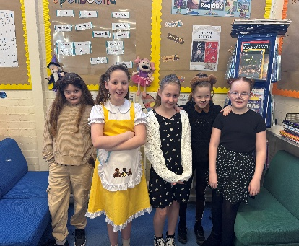
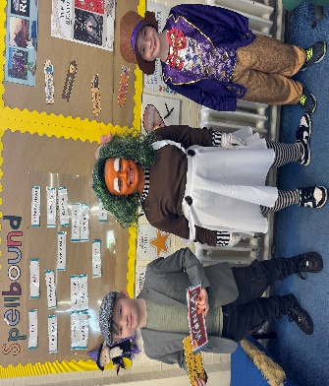
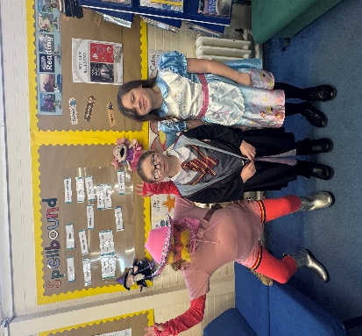
ATTENDANCE
Term 4
 1st – Brompton – 96.87%
 2nd – Northumberland – 96.08
 3rd – Palace 1 – 95.03%

Well done for amazing attendance
Keep up the great work!

Dates for your diaries:
2nd April – Last Day of Term
20th April – Start of Term 5
22nd April – Betteshanger Trip – Year 5 – Olympic Class
23rd April – Betteshanger Trip – Year 5 – Kew Class
30th April – Yr 1 Phonic Screening meeting – 2.30pm
w/b 4th May – Year 2 SATs Week
5th May – Betteshanger Trip – Year 4 – Regents Class
6th May – Betteshanger Trip – Year 4 – Kensington Class
6th May – NHS Vision Screening – Year R
8th May – VE Picnic Celebration – Years R & 1 – 2pm – 3pm
w/b 11th May – Year 6 SATs Week
12th May – Richborough Fort Trip – Year 3 – Northumberland Class
13th May – Frampton Farm Trip – Year R
15th May – Kearsney Abbey Trip – Year 2
18th May – Sports Day – Years R & 1 – am
19th May – Richborough Fort Trip – Year 3 - Greenwich Class
19th May – Sports Day – Years 4,5 & 6 - am
20th May – Frampton Farm Trip – Year R
20th May – Sports Day – Years 2 & 3 - am
20th May – Kent Test Talk – Year 5 – 3.20pm
21st May – Prize Assembly – 9am
22nd May – Last Day of Term
PE Kits
Years R, 1, 2 & 3
Polite reminder, please ensure that PE Kits are in school at all times
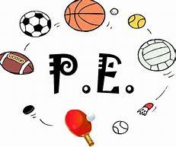

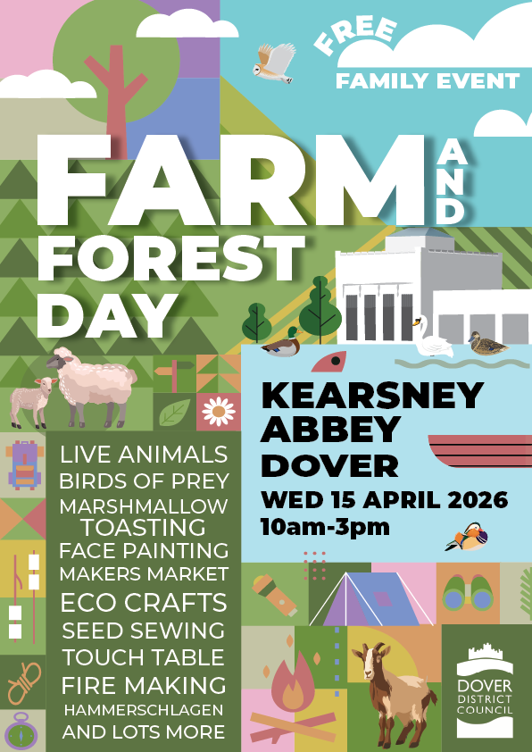

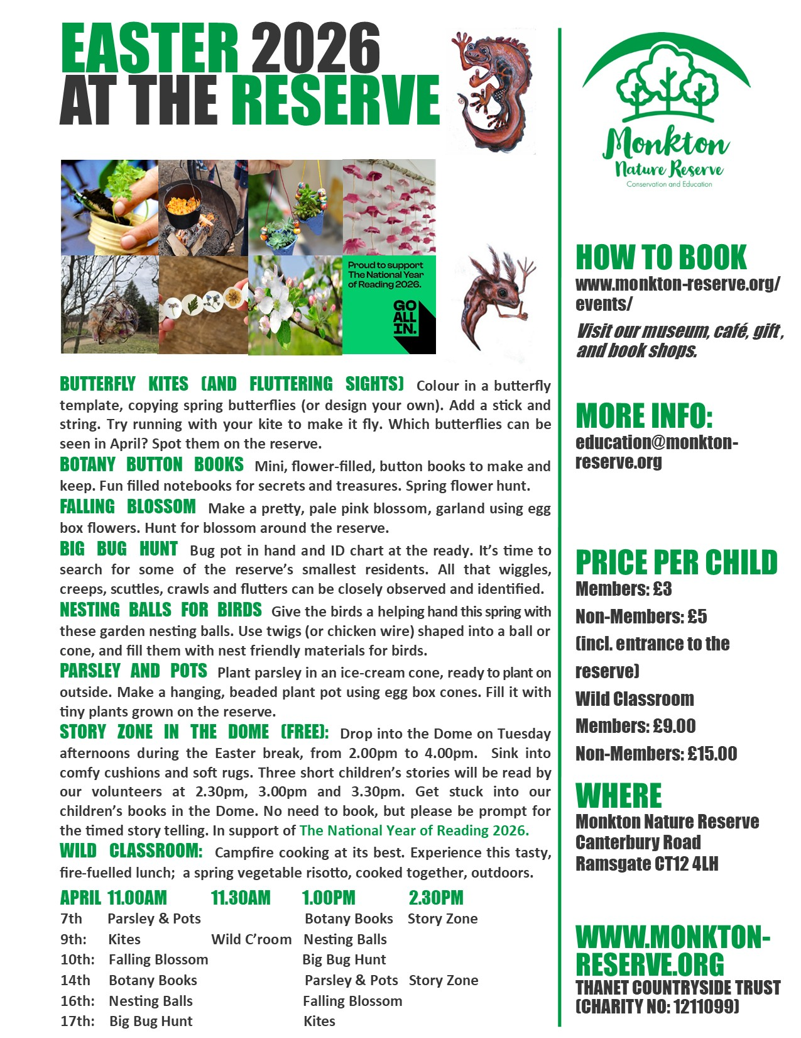

HAVE A LOVELY EASTER HOLIDAY



CHILDREN ARE BACK IN SCHOOL ON
MONDAY 20TH APRIL 2026

