
PE
WILL BE EVERY THURSDAY

This term, the children will be learning about sending and receiving. PLEASE MAKE YOUR CHIILD HAS A COMPLETE KIT.

Targets
- Master basic movements and skills.
- Communicate with a partner.
- Keep count of a score.
- Play basic games with a ball.
English

During literacy this term, we will be practising our writing through non-fiction pieces such as information posters, diary entries and menus. In these pieces we will be applying our new phonics to help us spell.

We will also be reading high quality texts that link to the theme each week.

Discovery

Discovery this term will be looking at the history of dinosaurs and what the landscape was like during this period. We will also be revisiting our knowledge of carnivores, herbivores and omnivores and applying it to different dinosaurs. Towards the end of term we will have an RE focus as we lead up to Easter.

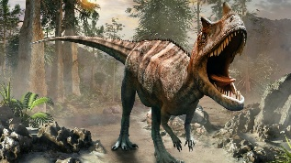

Topic Web
Dinosaur Planet
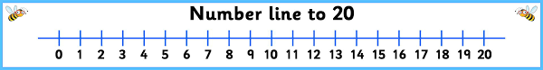

Maths

In maths, we will begin to explore and understand numbers up to 50. With these numbers, we will be understanding their value, counting in tens, and finding one more/ one less. We will also work on our number line skills, using them to estimate numbers.
Later in the term we will begin learning to measure length, volume and capacity.
The children will also develop their reasoning and mathematical word problem skills.

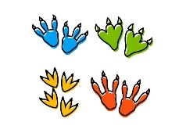
Phonics

This term, the children will continue to build upon their phonic knowledge and are now learning alternative sounds. We will continue to learn new tricky words. You should have received your child’s new home learning phonics packs so please use them to help with your child’s learning of phonics. This term phonics cards will be sent home to help your children learn alternative sounds. We will also send some alien words for your children to practice.
Each week your child will continue to bring home a reading book every day, thank you for always hearing your children each night.

Special experiences
The Dino Man
We have got the wonderful Dino Man coming to visit the school this term. They will bring a wealth of dinosaur knowledge with them as well animated dinosaurs for the children to interact with.
Fossil Hunting
We will also be fossil hunting at Folkestone Sands beach. More details of both trips will be online soon.

Art and DT

This term, we will be improving our DT skills. From making sock puppets to making dinosaur eggs, we will be getting very creative this term.
We will also be cooking this term, looking at healthy eating and how to prepare food.

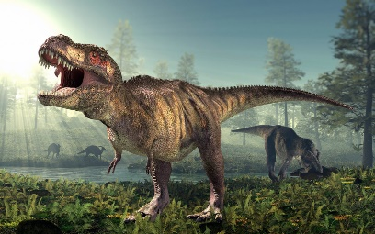
Our aim is to keep learning fun and exciting for all of the children in Year 1 therefore sometimes we will adapt and change our plans to suit their needs.

