
Green Park Community Primary School
December Newsletter

Message from Mr. Hawkins
As we reach the end of not just the Autumn term, but also 2025, my biggest message is one of gratitude. The education world has changed significantly in the past 12 months. The removal of SEND funding, changes to Ofsted inspections and now the prospect of a new National Curriculum are monumental shifts in how schools run. Despite this, my amazing team here at Green Park has navigated these changes without a word of complaint. We’ve created 3 fantastic SEND hubs across the school and I’d like to give a special thanks to Rachel Guy, Maria Harrison and the brilliant staff who run the Paddington classes every day. Our team have been busy preparing for our next Ofsted inspection. We don’t know when we will be inspected, but we do know that it will be this academic year. The new Ofsted framework provides a different perspective of a school and I am confident that we will have many strengths. We’re busy writing a brand new curriculum for Green Park, which will come into place in September 2026. All this happens behind the scenes and the staff team work so hard to make it happen, as well as continuing their great work every day, teaching the children.
This term has been busy, with Nativity Plays, Class Assemblies, Carol Concerts, Church Services and many trips. This week, we visit the Tower Theatre in Folkestone to see Jack and the Beanstalk. By the time we get to Friday, I know that everyone will deserve a holiday!
I hope you and your families will have a wonderful Christmas and a healthy New Year.

Here are some examples of our Year Group Blogs
For all other Blogs please see the School Website

Year 5 – Term 2 Blog: Fallen Fields
This term, Year 5 have been fully immersed in our World War 1 topic, Fallen Fields. It has been an exciting and thoughtful journey filled with hands-on learning, creativity, and special events that helped us understand life during the Great War.
Walking Through History: Our Trench Experience
One of the highlights of the term was visiting a real-life trench. Stepping down into the narrow, muddy pathway helped us imagine what daily life was like for soldiers on the front line. The children asked fantastic questions and reflected deeply on the sights, sounds and challenges the soldiers would have faced. It brought our topic to life in a way that books alone never could.
Painting the Past: War-Themed Artwork
Inspired by artists such as Paul Nash, the class created powerful war paintings. Using dramatic colour palettes and brushstrokes, the children captured scenes of battlefields, silhouettes of soldiers, and the stark contrast between peaceful skies and the chaos below.
Science – Forces in Action
In science, we explored forces and how they affect movement—perfectly linking to our history learning. We investigated gravity, friction, air resistance and even had a go carrying out some experiments! The children made excellent connections between scientific ideas and how forces would have affected soldiers and equipment during WWI.
Class Assembly – Sharing Our Learning
Our class assembly was a wonderful opportunity to share everything we’ve discovered this term and last. From letters to artwork and historical facts, Year 5 confidently presented their learning to families and the school. Their performance was thoughtful, informative and full of pride.
Christmas Concert on the Playground
To finish the term, we took part in our festive outdoor Christmas concert on the playground. With warm coats, bright smiles, and lots of enthusiasm, the children sang beautifully and helped spread Christmas cheer to everyone who came along.
What a fantastic term it has been! Year 5 have worked incredibly hard, shown curiosity, creativity and respect throughout our Fallen Fields topic, and ended the year with plenty to celebrate. We’re excited for what’s to come next term!

Year 1
Use QR Codes below, to see, what Year 1 have been learning about this term!



Christmas Fair
Congratulations to our raffle winners. Please collect prizes from Reception.
We would like to thank you for your continued support and donations to the school.
Dates for your diaries:

19TH December – Last Day of Term

5th January – Start of Term 3
9th January – Year 2 Immersion Day – Victorians – See letter sent out
12th January – Year 3 Immersion Day – Celtic Warriors – See letter sent out
26th January – Year 6 – Explorers Day (In school)
29th January – Year 3 - Dover Museum Trip
29th January – Year 5 – WonderDome in School
4th February – Child Behaviour Workshop for Parents – 9am -10.30am (all parents)
5th February – EYFS – Trip to Seaside Town
5th February – Year 6 - ‘Come and Look’ – 2.30pm
6th February – EYFS – Trip to Seaside Town
6th February – Years 4 & 5 – ‘Come and Talk’ – 2.30pm
10th February – Safer Internet Day
11th February – Year 4 - Dover Priory Trip
12th February – Year 2 – Dover Transport Museum Trip - am
12th February – EYFS – ‘Come and Play’
12th February – Year 2 & 3 ‘Come and Play’ – 2.30pm
13th February – Friendship Disco

13th February – Last Day of Term
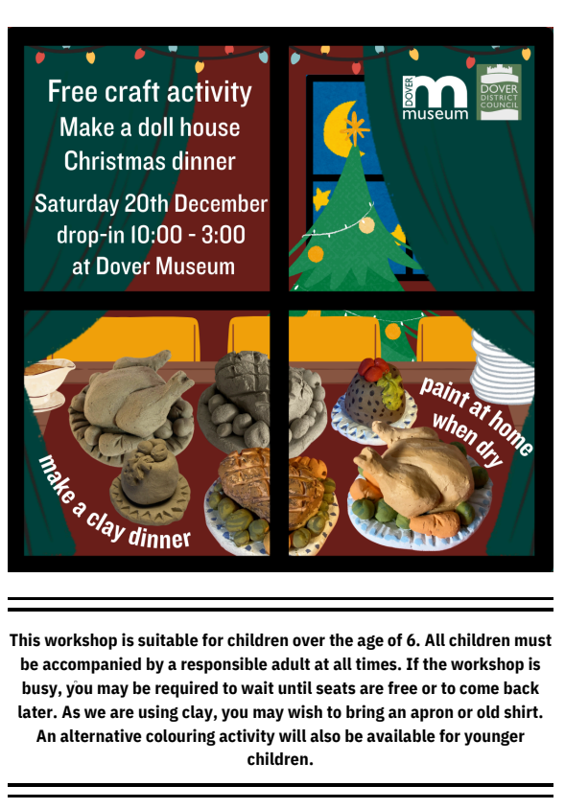

Brompton Class – 94.52%

Royal Class – 94.40%

Regents Class – 94.10%
ATTENDANCE
Term




Well done for amazing attendance
Keep up the great work!

PE Kits
Years R, 1, 2 & 3
Polite reminder, please ensure that PE Kits are in school at all times
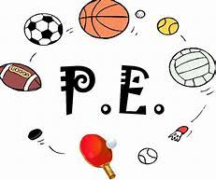

All the staff wish you all
a Merry Christmas
And a Happy New Year


We will see you all back at school on
5th January 2026

