
The Linces, Buckland Estate
Dover
Kent CT16 2BN
Tel: 01304 822663
Fax: 01304 824091
Email: headteacher@greenpark.kent.sch.uk

17th December 2025
Dear Parent/Guardian
Year 2 Victorians Immersion Day – Friday 9th January 2026

To introduce the children to their next topic ‘Street Detectives’, Year 2 will be having a Victorians immersion day on Friday 9th January 2026
Street Detectives looks at houses, shops and the local area. The children will explore how these areas have changed over time, looking at the Victorian era to make comparisons about jobs, schools and shops.
As part of the day, we would like to invite the children to dress up as a Victorian. You can be as creative as you like, or you can stick to something simple. Some ideas are shown below:
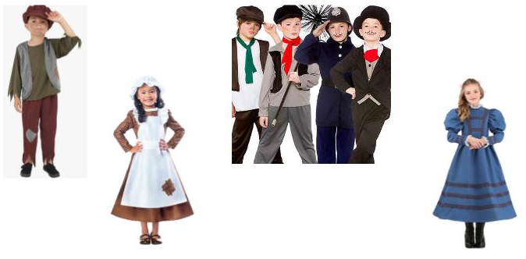

The children will take part in activities that will begin to introduce them to the Victorian age and explore the topics covered in the unit of study.
There is no cost to this day, and the activities will all take place in school during the normal school day.
We look forward to seeing our tribe of caveman after the half term break!

Many thanks
Mr M Carpenter
Year 2 and 3 Leader of Learning

