
The Linces, Buckland Estate
Dover
Kent CT16 2BN
Tel: 01304 822663
Fax: 01304 824091
Email: headteacher@greenpark.kent.sch.uk

4th December 2025
Dear Parent/Guardian
Year 3 Celtic Warrior Immersion Day – Monday 12th January 2026

To introduce the children to the second part of their topic ‘Through the Ages’, Year 3 will be having a Celtic Warrior immersion day on Monday 12th January 2026.
Through the Ages teaches the children about the earliest eras of civilization, beginning with the Stone Age and ending with the Iron Age. This term, the children will focus on the Iron Age.
As part of the day, we would like to invite the children to dress up as a Celtic Warrior. You can be as creative as you like, or you can stick to wearing something tartan and decorating your face with blue “war paint”.
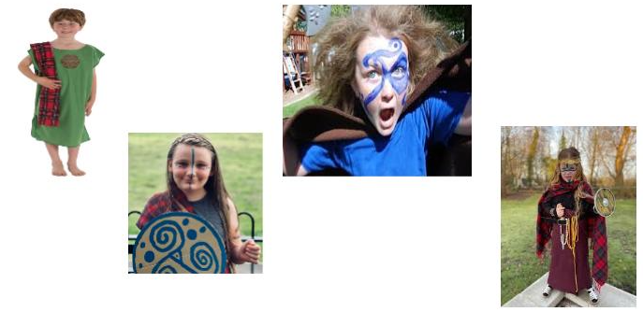

The children will take part in activities that will recap their learning about the Stone and Bronze Ages, before giving them an insight into the final era of human pre-history.
There is no cost to this day, and the activities will all take place in school during the normal school day.
We look forward to seeing our tribe of caveman after the half term break!

Many thanks
Mr M Carpenter
Year 2 and 3 Leader of Learning

