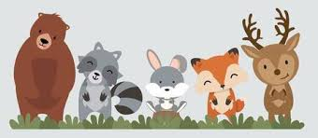

Year 1
Term 5 Enchanted Woodland
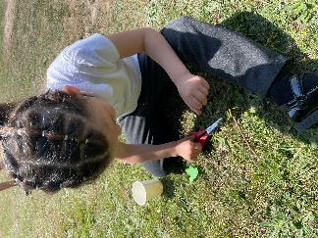
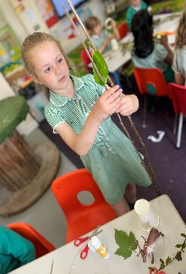
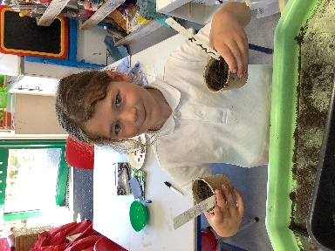
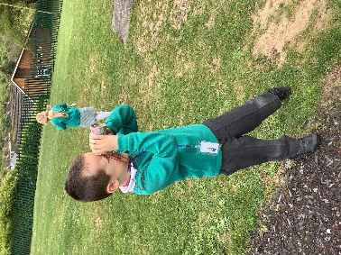
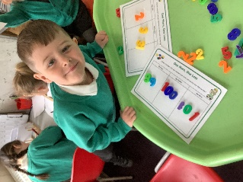
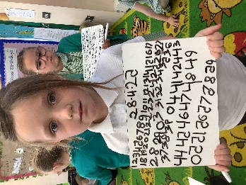
Here is what we have been up to…Learning and laughing all the way!

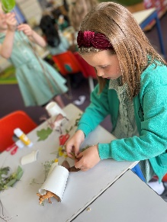
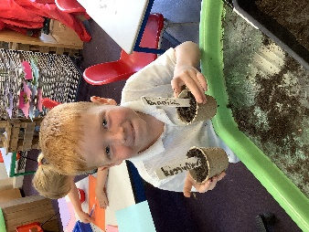
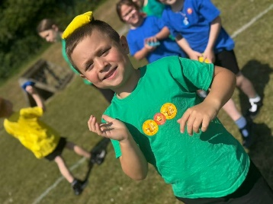
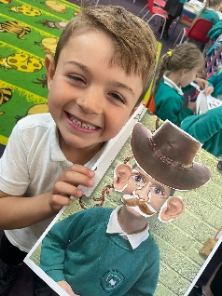
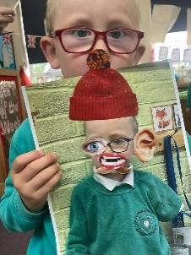
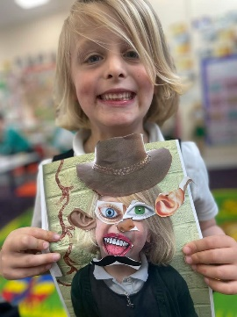
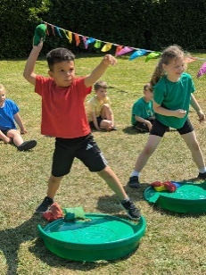
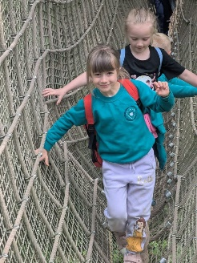
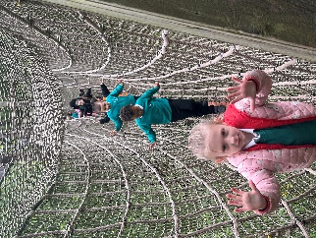
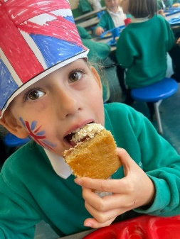
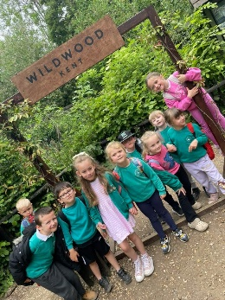
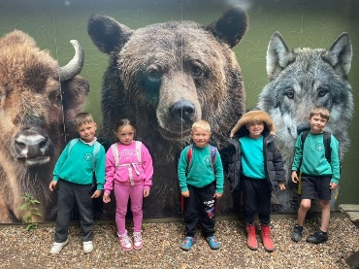
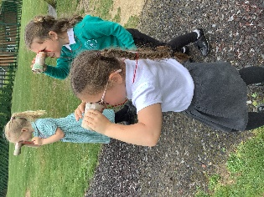
Sports day was so much fun!
In Literacy we have been building habitats for the animals in the story of After the Storm and then writing instructions on how to make them.
In Art we have been looking at famous portrait artist and their work. We have drawn our own portraits and had lots of fun making our collage portrait.
Our trip this term was to Wildwood near Canterbury. We spotted lots of woodland animals, found out about their habitats. We were brave and resilient walking over the bear enclosure. It was a great day out!
We celebrated VE day with jam and cream Victoria sponge.
In Maths we have been writing numbers to 50 and beyond. Finding 1 more and 1 less.
In Discovery we have learnt about plants and how they grow, looking at each part with a magnifying glass. We also made binoculars to spot any common birds found in the UK.

