During term 5, our topic was Ready, Steady, Grow…

The children have had a fantastic term, where we have read the following books:

How I grow
Oi Frog!
Jack and the Beanstalk
Handa’s Surprise
Can I eat a Rainbow?

Throughout the term, the children have had some amazing learning opportunities. They have learnt all about the life cycle of plants, frogs and chicks, looked at a famous artist (Van Gogh) and had a go at recreating his famous art work ‘The Sunflowers’ and planted sunflower seeds, discussing what a plant needs to grow and how to care for a plant. For our school trip, the children visited Frampton Farm, where they were farmers for the day – the children sorted the animal feed, fed the animals their breakfast and learnt all about life on a farm – it was hard work! They also learnt about healthy eating and how different coloured foods help different parts of your body.

The children were very excited to witness our chick’s hatching – they were amazed that a chick could fit inside an egg! They enjoyed watching them grow during the short time they were with us and were very calm and caring when handling them. Although the children were sad to see them go, Mrs Gough, one of our TAs adopted them, which means they will come and visit!

This term, the children also took part in sports day, which was a brilliant day for all! They took part in a sprint, obstacle race and sack race – the children behaved wonderfully and cheered on their friends, showing great sportsmanship! In the afternoon, they worked as a team during potted sports, which was great fun! They had a go at target throwing, javelin, beat the goalie, golf, skipping and an obstacle course. The children showed great resilience and teamwork.

We also had a come and play session in our forest school. The children were very excited to invite their grown-up’s in to explore and have fun in the forest. They even got to toast a marshmallow!

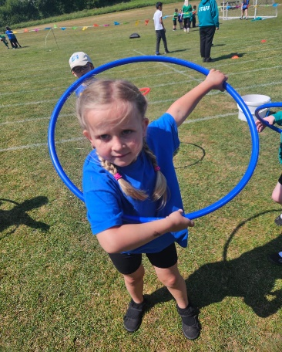
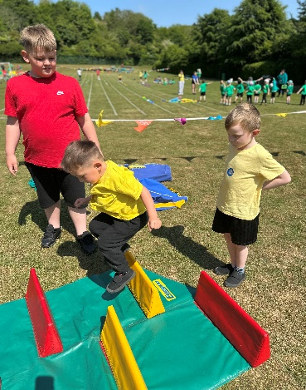
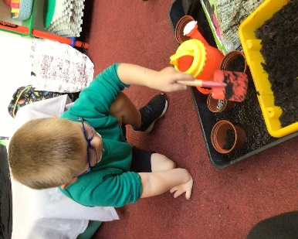
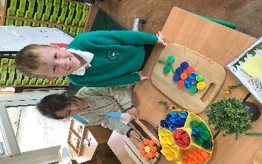
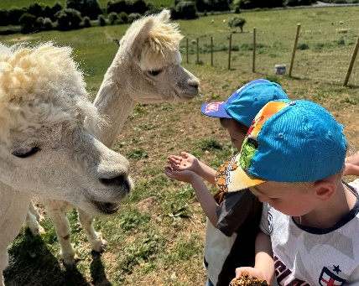
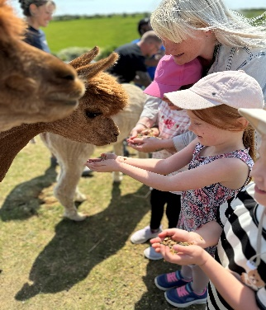
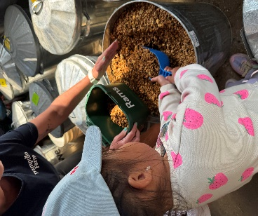
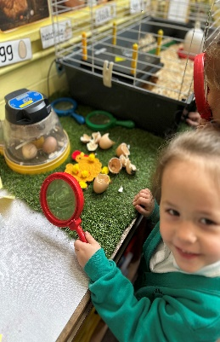
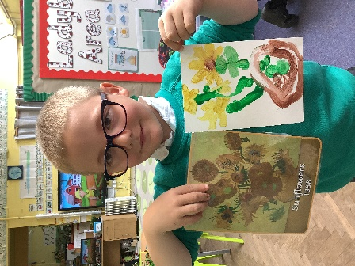
We have had a very busy term and could not be any prouder of the progress the children are making. Term 6 promises to be another busy term, also it is their final term in Palace class so we will be making this the best one yet…


