Mental Health Home Page

Welcome to Green Park Community Primary School’s mental health page. This page has been developed in collaboration with Everlief Child Psychology and provides a wide range of support for you and your child.

What Is Mental Health? | 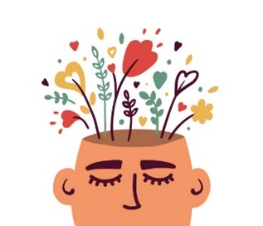
Tips for listening to a child | 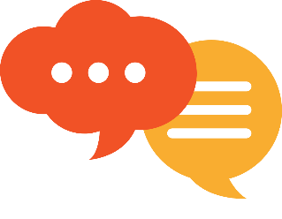
Resources for common issues:  Anxiety including exam stress  Behavioural Issues  - Bullying and friendship issues  Depression  Low Self-Esteem  OCD  Self-harm | 
General Support Services | 
School contacts | 

What Is Mental Health?

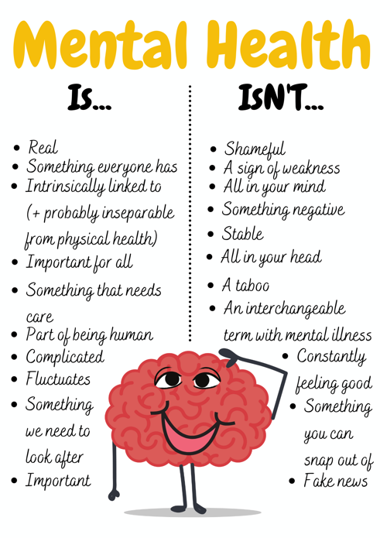
Mental health encompasses social, physiological, and emotional wellbeing, involving the ability to function and cope with daily life. Contrary to popular belief, mental health is relevant to everyone, not just those with mental health problems. Mental health can fluctuate over time, similar to physical health.

The term ‘mental health’ is used to describe various conditions that cause changes in feelings or behaviours. Examples include anxiety, depression, obsessive compulsive disorder, eating disorders, and psychosis. This list is not exhaustive.

It is worth noting that one in ten children will experience mental health issues, and more than 50% of these issues begin before the age of 14. For further statistics on mental health, you can find information here: https://www.mentalhealth.org.uk/explore-mental-health/statistics/children-young-people-statistics

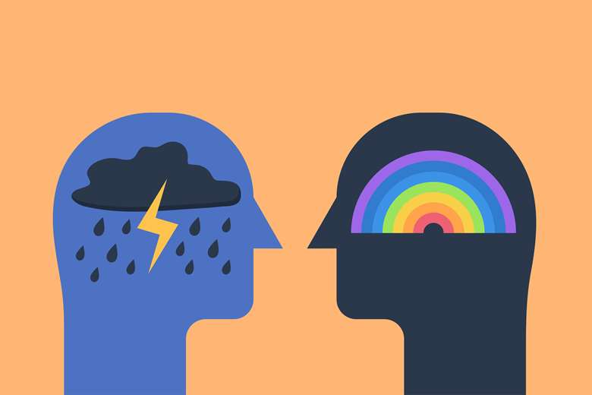
Children and young people undergo various behavioural changes as part of their growth process. While some changes are typical for young people, in certain cases, they may indicate the development of mental health conditions. Action for children has devised an easy way to help adults recognise common signs that can be useful in identifying concerns about a child or young person’s mental health. They can be remembered using the acronym ‘MASK’.

M – Mood. Look out for argumentative behaviour, aggression, negative emotions, self-criticism, and withdrawal in children and young people.
A – Actions. Changes in eating or sleeping patterns, signs of bullying, substance misuse, or self-harm (such as cutting, burning, or hair pulling) can indicate mental health issues.
S – Social. Losing touch with friends, changing friendship groups, appearing lonely or withdrawn, and losing interest in school or hobbies can be signs of mental health illnesses.
K – Keep talking. Children and young people may not readily express their feelings. Don’t give up, keep asking how they are feeling, let them know you care, and that you’ll be there for them.

2.Tips for listening to a child

Discussing mental health can be challenging. Children and young people may worry about being labelled or stigmatised, upsetting others, or the potential consequences. Parents and carers may have concerns about saying the wrong thing, exacerbating the situation, or treatment options.

Creating a safe and loving environment is crucial for children with mental illness. Maintain a supportive and low-stress atmosphere at home. Structure can be helpful in reducing stress. Parents and carers can try making a contract with their child, ensuring they feel comfortable talking or finding alternative ways to communicate when they’re struggling e.g., texting. This gives children a safe outlet to express their feelings.

A safe environment also entails open communication and dialogue. Encourage your child to understand their own mental health by regularly checking up on their wellbeing. Help them understand how to manage their emotions, identity feelings, and recognise their influence on behaviour. The ‘Triangle of Feelings’ can be useful in this regard. This allows young people to understand how we think, feel, and behave, and how each influences each other.
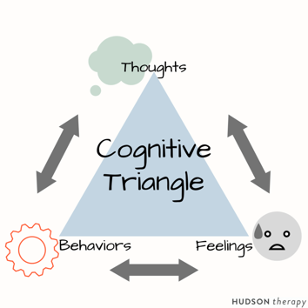

You are not alone. There are numerous resources available to assist you and your child. The provided links connect to organisations and charities dedicated to supporting children, young people, and their parents through episodes of mental health.

If you have concerns about your child, you can also reach out to your GP, school nurse, or school’s safeguarding team for support and guidance.

3. Resources for Common Issues

Anxiety:
- They Are The Future: https://www.theyarethefuture.co.uk/stress-and-anxiety/
- The Parent Survival Guide To Back To School Anxiety: https://www.theyarethefuture.co.uk/help-beat-back-to-school-anxiety-with-this-strategy/
- The 15 Best Grounding Exercises For Kids: https://www.theyarethefuture.co.uk/grounding-exercises-for-kids/
- Panic Attacks In Children, How To Help: https://www.theyarethefuture.co.uk/panic-attacks-in-children-how-to-help/
- Motivational quotes to help your child with exams: https://www.theyarethefuture.co.uk/exam-confidence-motivational-quotes/
- Anxiety UK: provides live chat and email support for children and young people dealing with anxiety. https://www.anxietyuk.org.uk
- No Panic: offers a helpline for young people who experience panic attacks, OCD, phobias, and other anxiety disorders. http://www.nopanic.org.uk

Behavioural Issues:
- They Are The Future: https://www.theyarethefuture.co.uk/behaviour-support/
- Managing Behaviour, A Guide For Parents: https://www.theyarethefuture.co.uk/managing-difficult-behaviour/
- How To Deal With An Argumentative Child: https://www.theyarethefuture.co.uk/how-to-deal-with-an-argumentative-child/

Bullying and friendship issues:

- What to do if your child is being bullied: https://www.theyarethefuture.co.uk/what-to-do-child-being-bullied/
- Help your child with friendship group dynamics: https://www.theyarethefuture.co.uk/friendship-group-dynamics/
- Is your child’s behaviour difficult after school: https://www.theyarethefuture.co.uk/childs-behaviour-difficult-after-school/

Depression:
- Charlie Waller Memorial Trust: Includes information for children and young people on recognising signs of depression. https://charliewaller.org
- My CAHMS Choice: Provides information and support for young people referred to the CAHMS system. http://www.mycamhschoices.org
- Students Against Depression: Offers information, advice, and real-life stories for students struggling with depression. https://www.studentsagainstdepression.org

Low Self-Esteem
- They Are The Future: https://www.theyarethefuture.co.uk/self-esteem-children/
- Helping your child cope with setbacks: https://www.theyarethefuture.co.uk/helping-child-cope-setbacks/
- Teen Self Esteem Activities: https://www.theyarethefuture.co.uk/teen-self-esteem-activities/
- Teen Self Esteem Statistics and Facts: https://www.theyarethefuture.co.uk/teen-self-esteem-statistics/

OCD:
- They Are The Future: https://www.theyarethefuture.co.uk/?s=ocd
- OCD In Children, Guidance For Parents: https://www.theyarethefuture.co.uk/ocd-in-children/
- Autism vs OCD: https://www.theyarethefuture.co.uk/autism-vs-ocd-children/
- OCD UK: Offers information and support on OCD, including online support forums. http://www.ocduk.org

Self-Harm:
- Life Signs: Provides information and support on self-harm in children and young people. https://www.lifesigns.org.uk
- National Self-Harm Network: Offers a forum that provides crisis support, resources, and advice on dealing with self-harm. https://www.nshn.co.uk
- Self-Harm UK: Provides information for parents and professionals on self-harming behaviour. https://www.selfharm.co.uk

4. General Resources

National Helplines for Adults and Children:

Childline – A supportive platform where children and young people can discuss their worries with someone. They can access this service online at: http://www.childline.org.uk or through the phone at: 08001111

NSPCC – A charity dedicated to combatting child abuse. They have a helpline staffed by trained professionals who can offer expert advice and support to anyone concerned about a child, parents or carers seeking guidance, or professionals in need of information. The helpline number is 08088005000. In addition to this, the NSPCC has established a helpline specifically for children, young people and worried adults and professionals dealing with abuse at school. This dedicated helpline can be reached at: 0800136663. Further information can be found on www.nspcc.org.uk

The Samaritans – Offer a confidential helpline that provides support and advice to individuals experiencing emotional distress. They can be reached on 116123 or visit www.samaritans.org for more information.

Young Minds Parentline – Offers information and advice for anyone concerned about a child or young person under the age of 25. The helpline can be reached on 08088025544 or visit https://www.youngminds.org.uk/parent/parents-helpline-and-webchat

Papyrus – A charity focused on preventing youth suicide. They have a helpline for individuals concerned about themselves or somebody they know. Helpline can be accessed on 08000684141 or visit http://www.papyrus-uk.org

General Mental Health Advice and Support:

Action for Children – Provides practical and emotional care and support to children, young people, and their parents or carers. They work to ensure that the voices of children and young people are heard, and advocate for lasting improvements in their lives. https://www.actionforchildren.org.uk/our-work-and-impact/children-and-families/good-mental-health/

Doc Ready – Helps prepare young people for their first visit to the GP to discuss their mental health. http://www.docready.org/#/home

Headspace: A meditation and stress relief guide. https://www.headspace.com
SAM (Self-Help For Anxiety Management): Anxiety management assistance with interactive games, tools, and an anxiety tracker. http://sam-app.org.uk

Healthy Minds: A problem solving tool aimed at students. https://www.healthyminds.org.uk

Kooth – An online platform that offers counselling and support services for children and young people. https://www.kooth.com

Mind – A national mental health charity that provides information and advice on mental health. http://www.mind.org.uk
Mood Panda: Combines mood tracking with a social network, allowing children and young people to choose whether to share their mood privately or publicly for support. https://moodpanda.com

Teenage Helpline – Provides peer-to-peer mentoring services for young people throughout the UK. https://teenagehelpline.org.uk

Drugs and Alcohol:
- Addiction: Provides information about drug and alcohol problems. https://www.wearewithyou.org.uk
- Nacoa: Offers information and support for children and young people affected by a parent’s alcohol use. http://www.nacoa.org.uk
- Cranstoun: Provides help for adults and children with alcohol and drug problems. https://www.cranstoun.org

Eating Disorders:
- Beat Eating Disorders: Offers helplines, online support, and self-help groups for all types of eating disorders. https://www.beateatingdisorders.org.uk

LGBTQ+:
- Stonewall: Campaigns for the equality of lesbian, gay, bisexual, and transgender people across Britain. https://www.stonewall.org.uk

Supporting Children and Young People with Their Gender Identity:
- The Proud Trust: Provides resources and information to improve the lives of LGBTQ+ young people. https://www.theproudtrust.org
- Gendered Intelligence: A charity focused on increasing understanding of gender diversity and improving the quality of life for transgender people. https://genderedintelligence.co.uk

For more parenting and wellbeing support for parents of school aged children please visit https://www.theyarethefuture.co.uk . Brought to you by a clinical psychologist, you can also access parent workshops, online courses, and articles to help your family thrive.

5. School Contacts

Designated Safeguarding Lead and Senior Mental Health Lead:
Richard Hawkins: headteacher@greenpark.kent.sch.uk
01304 822663

